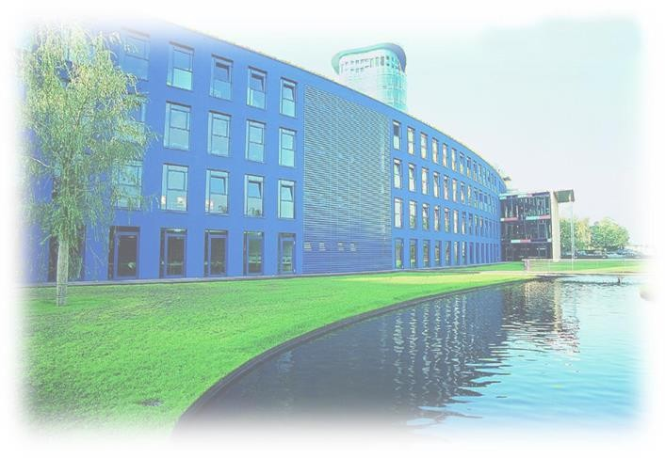
Software Architecture & Development

Project Title: Charity Web Application

Panchakshariah Harokyathanahalli Siddalingappa – 11013293
Tanuja Jadhav – 11013745
Zeba Gunjarge – 11013744
Bhagyashree Lakshmisha – 11013624
T. venu Sukanya – 11013711
Mentors

Dipl.-Inform. (FH) Christoph Hahn
Dr. Andreas Jäger

Table of Contact
- Introduction_________________________________________3-5
  - Project Description
    - Natural Calamities
    - Education Charity
    - Medical Charity
    - Animal Charity
  - Target Structure
    - Initial State
    - Vision
    - Objective
  - Milestones
- Technology/Framework & Software Architecture____________6-8
  - Technology/Framework
  - Software Architecture
- UML Approach_______________________________________9-12
  - Use Case Diagram
  - DFD Diagram
  - Sequence Diagram
  - Activity Diagram
- Screenshot__________________________________________13-19
- Future Enhancement__________________________________ 20
- Conclusion__________________________________________ 21

- Introduction
A Charity is a non-profit organization, in which functions are independent. They are civil societies which are well organized in community and serves social, political, cooperative and commercial purposes. The key objective of a charity is, welfare of public sector focusing mainly on quality of life (example: Natural calamities, Education, Medical and Animal) and other social service.
The definition of charity differs from one country to another, which has large diverse body of organization occupied in a vast range and taken to different forms in different parts of world. Some may have charity status while in other hand they may have political, religious, or other interests. Usually they are funded in form of donations, but some avoid legal funding and they primarily run through volunteers.
Charity is an NGO activity in which people who are willing to help others in need, but they will not have the right platform. So, these people can help with this charity website. Here, people can also form voluntary groups and serve people in local, national and international level
Charities are driven by a person’s natural interest, which performs variety of functions that helps to bring concern to citizens and encourage them to participate in social welfare. Some of them are organized in specific issues such as natural climates, environment, health.

  - Project Description

The project plan is to provide a well-designed website which is the best way for our charity to get consideration where we can promote your work and gain the trust of people ,and make an even bigger uplift, where we turn your non-profit organization into a beneficial tool and raise money up in which we can deliver it to a specific purpose according to the requirement on various projects to meet a specific need or purpose depending on the requirement.

The primary objective is social welfare which mainly focuses on quality of life established exclusively for public benefit (example: education and other activities serving the public interest or common needs). The purpose is to raise awareness of the causes and bring out some difference from the donations we get form people, which leads to new directions in social life and changes a person’s lifestyle.

We would like to mention our team’s individual contribution for this project.

Responsibilities | Zeba Gunjarge - 11013744 | Tanuja Jadhav - 11013745 | Panchakshariah Harokyathanahalli Siddalingappa – 11013293 | Bhagyashree Lakshmisha - 11013624 | T. venu Sukanya - 11013711
Database | 
Server
API
Postman | 
HTML
CSS
React JavaScript
Report

    - Natural calamities:
A Natural disaster is a major caused by bad natural processes of the earth. Examples floods, hurricanes, volcanic, earthquake and other geological processes due to which loss of life, property damage and economic damage. We mainly focus on highly impacted areas by organizing events where we can motivate people for funds raising. Here we gather the basic thing that are donated by people
- By sending money to organization disaster relief.
- Organize fundraisers to raise money.
- Donating clothes and food to affected areas.

    - Education Charity:
Education Charities makes possible for all students of all ages from pre-school to graduate. Which provides services and opportunities which makes more effective and more accessible to students for all backgrounds. We Organize events through which people who are willing to donate can donate. Even we Organize programs and services like
- Adult education.
- Education policy and reform.
- Scholarships and financial support.
- Special education mainly focusing on disability.

    - Medical charity:
It’s a multipurpose organization that seeks cures for diseases and disorder and promote medical by providing service. We Organize medical health camp where people get free health check-up for those who can't afford, and we make awareness programs to motivate people for quality of life.
- We Organize one day medical camp where people can get free health check-up and medicines.
- We raise funding for medical equipment.

    - Animal charity:
Animal charity, which is used to protect animals, defend and provide the basic service for wild animals. This Organization also preserve wildlife and protect species, seek way to promote habitats over time.
- Where we provide medical services for animals.
- We take care of abundant animals and give new hopes.
- We provide adoption options to people where they can adopt animals.

  - Target Structure
    - Initial state
Charity organization requires social support for those people who can donate in our website so we can describe the function of our organization to help others and encourage them donating for a good cause.
    - Vision
To achieve goals and create successful events which helps to achieve our target and learn as much as possible. our target is a group of people who are fundraising in order raise funds to our community. Our priority is to design a website and play role in promoting our organization through which we can motivate people for raising money and bring awareness to them and change their way of thinking.

    - Objective
- High level objectives-
- To increase the fund raising and encourage people for social welfare activities.
- Result objectives-
- Easily accessible website.
- Benefits given to the people in need.
- Process objectives-
- To meet the milestone of our project.
- Marketing and branding to increase fund raising.
- Personal objectives-
- Be a part of the charity organization and increase funds and giving social awareness to the people.

  - Milestones
- Before thinking, establishing big support is step one, then required amount of research is needed before stepping into it.
- A new charity organization needs to know the fact that the work cannot be done alone. So, building up a team is important.
- First, we need a blueprint of the ongoing causes and then begin to support people who care about the cause and understand their needs.
- Running a new organization needs compassion and track the measure of work and Raising money.

- Technology/Framework and Software Architecture
  - Technology/Framework
- React JS:
React js an open source JavaScript library which is used for handling user interface specifically for single page applications. It's used for handling view layer for Web and mobile apps. It also allows to create reusable UI components.
- React give ability to work with a virtual browser which is more friendly.
- It acts as an agent between developer and real browser.
- It is easier to maintain and flexible due to its modular structure.
- It provides high performance.

- Express JS:

Express js or simply express is a web application framework for nodes. Js, it is a open source software which is designed for building Web applications and API. Express is minimal, open source and flexible node. Js web app framework designed to make developing websites, Web apps and API much easier. Which supports multiple templating engines to simplify generating HTML.
- It used to design single - page, multi - page and hybrid Web applications.
- It defines routing TABLE.
- It allows to dynamically render HTML page based on passing arguments to templates.
- Postman:
Postman is an API client which is used to develop, test, share and document API's. Postman is all about API where we can create API manual as well as automation testing of API. Where we can share and Colbert API and create documentation of API. We can add new collection, update the collection, update the environments or add and run monitors directly through API. This enables programmatically access data stored in Postman account.

- MySQL workbench:
MySQL workbench is a unified visual tool for database architecture, developer and database administrator. MySQL workbench provides data modelling, sql development and comprehensive administration tools for server configuration, user administration, backup and much more. Provides an easy to use interface for performing the many task involved when working with databases.
- Supports creation of multiple models in the same environment
- It supports all objects such as tables, views, stored procedure, triggers
- MySQL workbench has a built-in model validating utility that reports any issue that might be found to the database modeler.
- It allows for different modelling notations and can be extended by using LUA scripting language.

  - Software Architecture

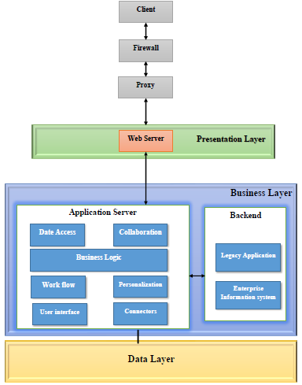
Fig 2.2 Software Architecture

The web application arranged over protocols and uses a client-server model, so it is natural that layered architecture would be suitable for developing the web application. We are using three-layer architecture, because it overcome the scalability of two layered client-server architecture. The main advantage of using layered model in software development, because it is easier to know exactly what each part of the application does and it also easier to build the application, to investigate it and to keep up and reuse the code. Web application is classified in to three-layer architecture.
1. Presentation Layer
2. Business Layer
3. Database Layer

- Presentation Layer: In computer networking, the layered concept of networking was developed to accommodate changes in technology. Each layer of a specific network model may be responsible for a different function of the network. Each layer will pass information up and down to the next subsequent layer as data is processed.

- Business Layer: The function of a business layer is to acts as one of a chain of server computers that service a request or transaction from, he is consuming client’s computing device. It does security, stores files, caches data that the database does not need to be interrogated for, validates that the user’s input is correct, tells the web server if there is a problem with any other computer, allows configuration, and acts as a hub to communicate with other computers. It does a few other things as well, but those pare the important things that it does.

- Database Layer: Inside data layer many technologies can be used and most of the web application uses relation database, but current trend of the market is MySQL (relational database). Some of the key characteristics of MySQL are as follows:

- Relational model will be used.
- Running well on cluster.
- Open source.
- Mainly designed for 21st century web development.
- Authentication.
- Remote configuration.
- Crash reporting.
- Real-time messages/notification (pushup).

3 UML Approach

A diagram is the graphical presentation of a set of elements, most often rendered as a connected graph of vertices and arcs. you draw diagram to visualize a system from different perspective, so a diagram is a projection into a system. For all but most trivial systems, a diagram represents an elided view of the elements that make up a system. The same element may appear in all diagrams, only a few diagrams, or in no diagrams at all. In theory, a diagram may contain any combination of things and relationships. In practice, however, a small number of common combinations arise, which are consistent with the five most useful views that comprise the architecture of a software-intensive system.

3.1 Use Case Diagram

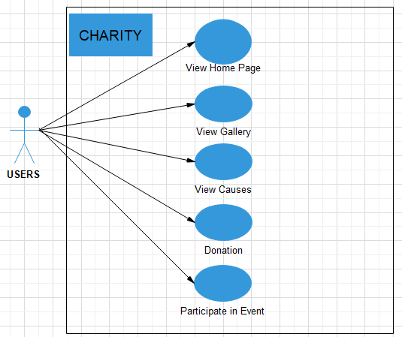

Fig 3.2: Use case diagram

3.2 DFD Diagram (Data flow Diagram)

A data flow diagram (DFD) is a graphical system model that shows all the main requirements for an information system in one diagram: inputs and outputs, processes, and data storage. A DFD describes what data flows rather than how it is processed. Everyone working on a development project can see all aspects of the system working together at once with DFD. That is one reason for its popularity. The DFD is also easy to read because it is graphical model. The DFD is mainly used during problem analysis. End Users, management, and all information systems workers typically can read and interpret the DFD with minimal training.

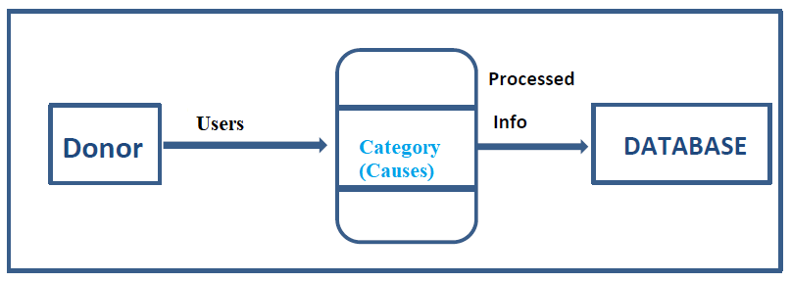
Fig 3.2: Donation DFD Diagram

3.3 Sequence Diagram

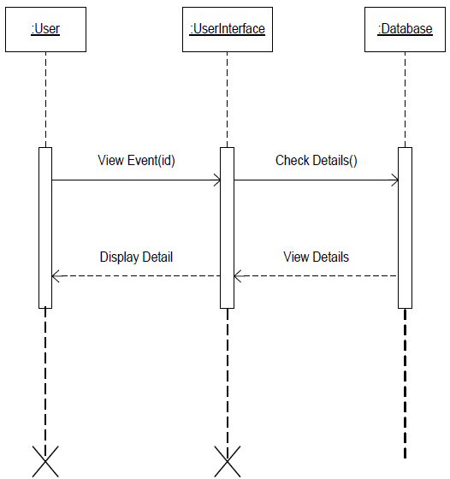

Fig 3.3: View info Sequence Diagram

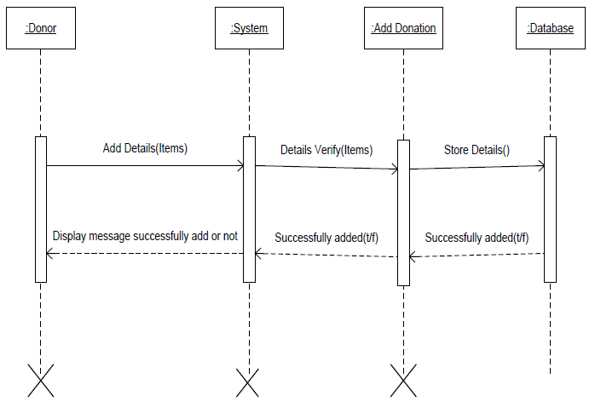

Fig 3.3: Donation Sequence Diagram

3.4 Activity Diagram

An activity diagram shows the sequence of steps that make up a complex process, such as an algorithm or workflow. An activity shows flow of control, like a sequence diagram, but focuses on operations rather than an object. Activity diagrams are most useful during the early stages of designing algorithms & workflows. Here is some advice for activity diagram:
- Don’t misuse activity diagrams.
- Be careful with branches & conditions.
- Be careful with concurrent activities.
- Consider executable activity diagrams.

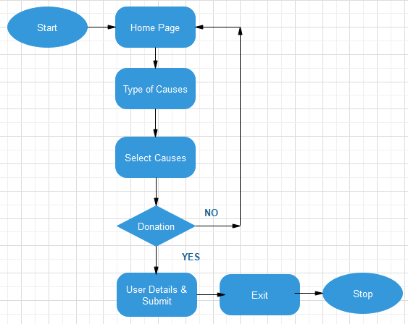
Fig 3.4 Activity Diagram

4 Screenshots
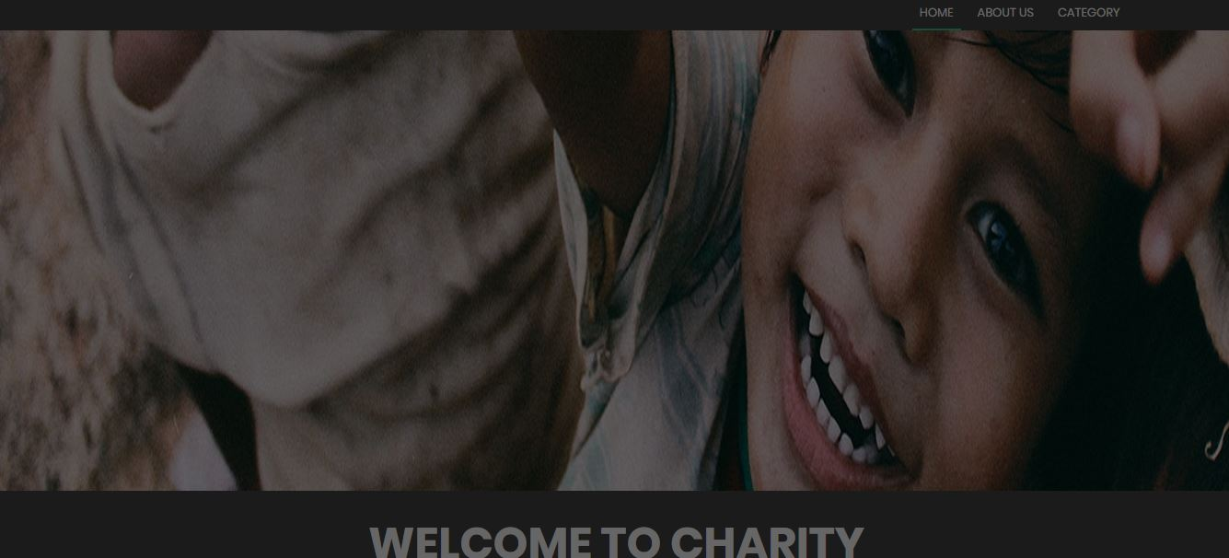
Home Page
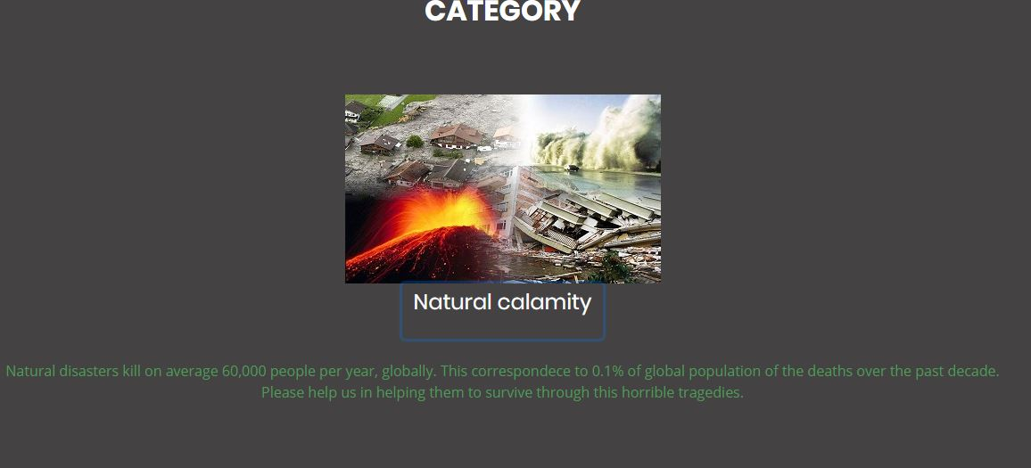
Information about Natural Calamity.
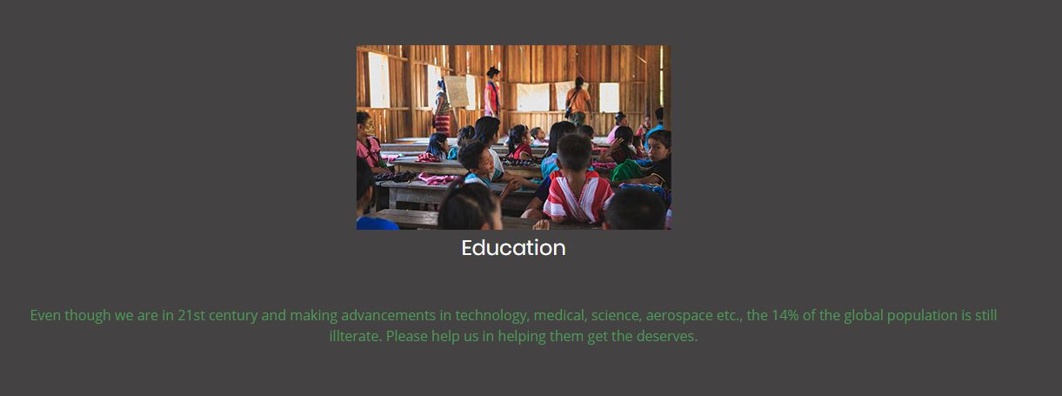
Information About Education Charity.
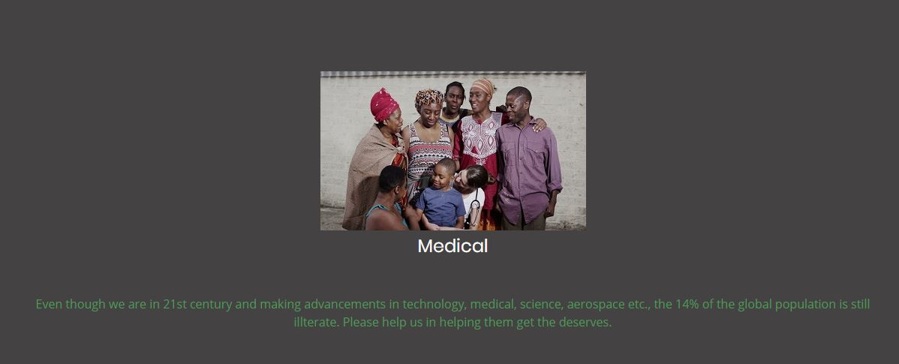
Information About Medical Charity.
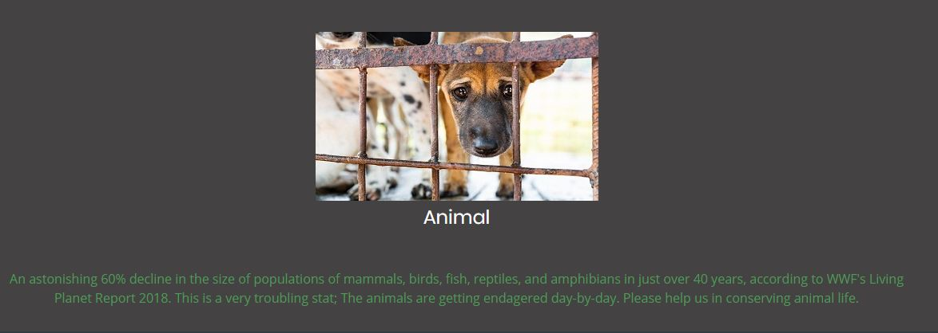
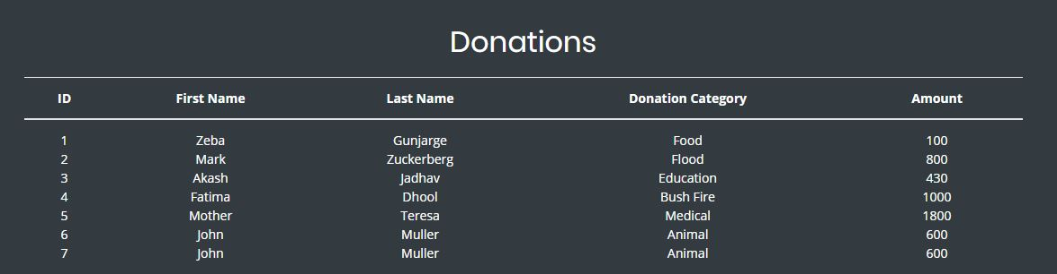
Summary of Donation
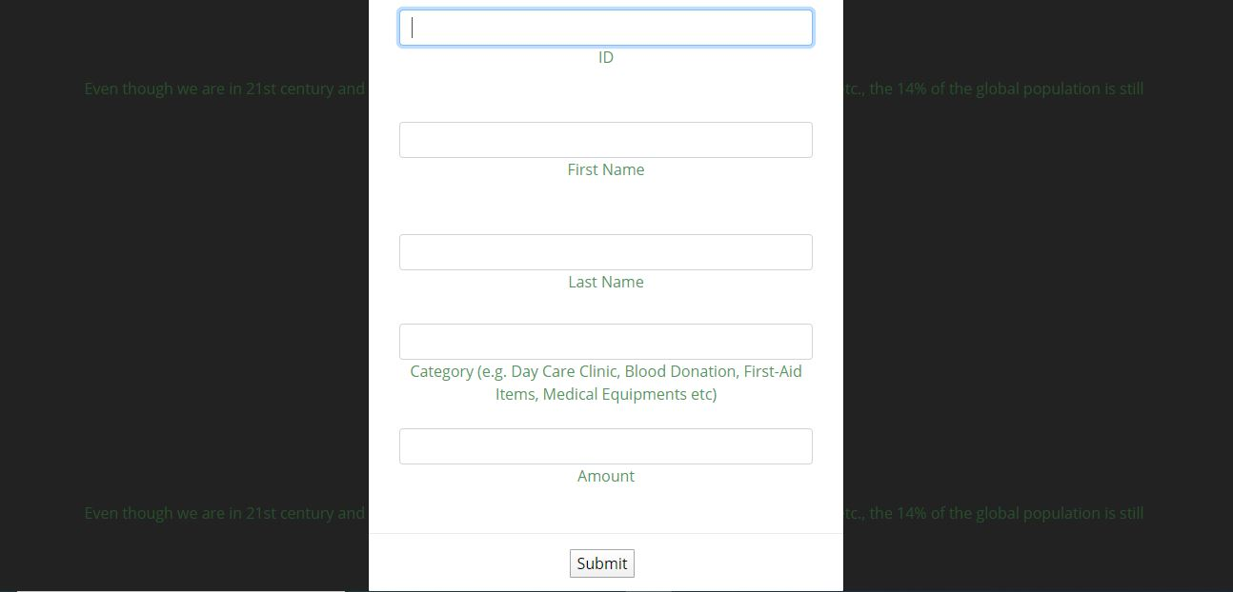
Donation Form
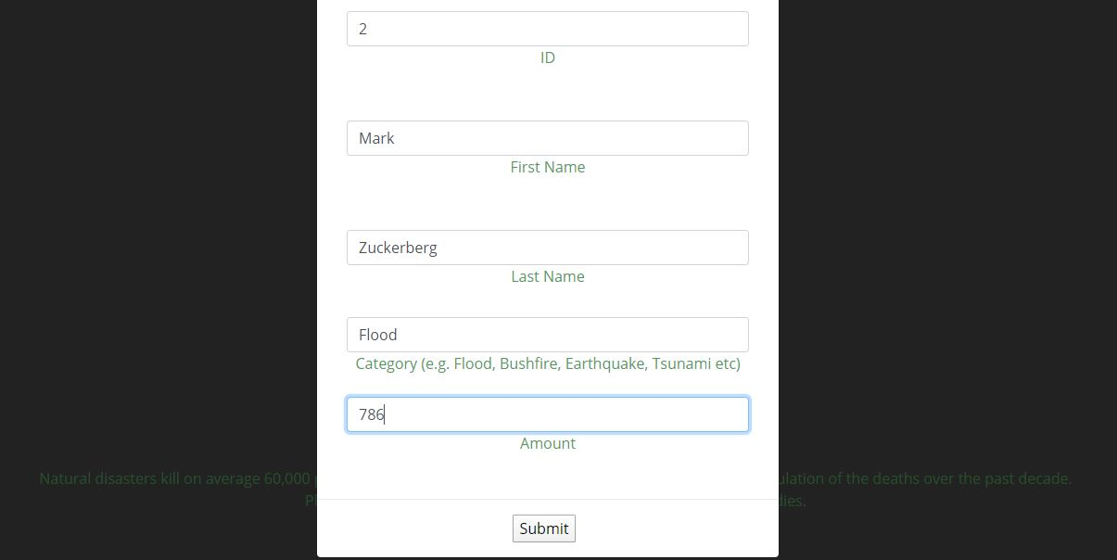
Donation Details
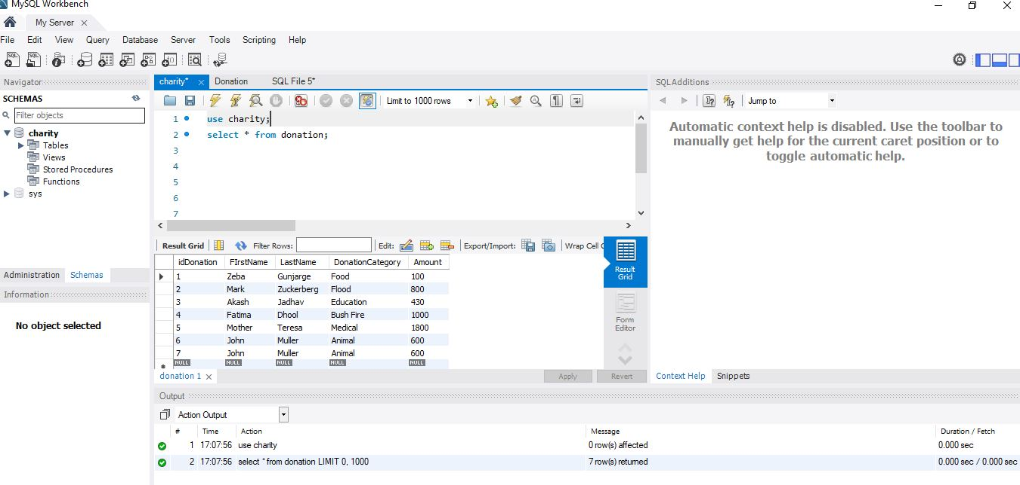
MySQL Workbench Database
Postman Screenshot
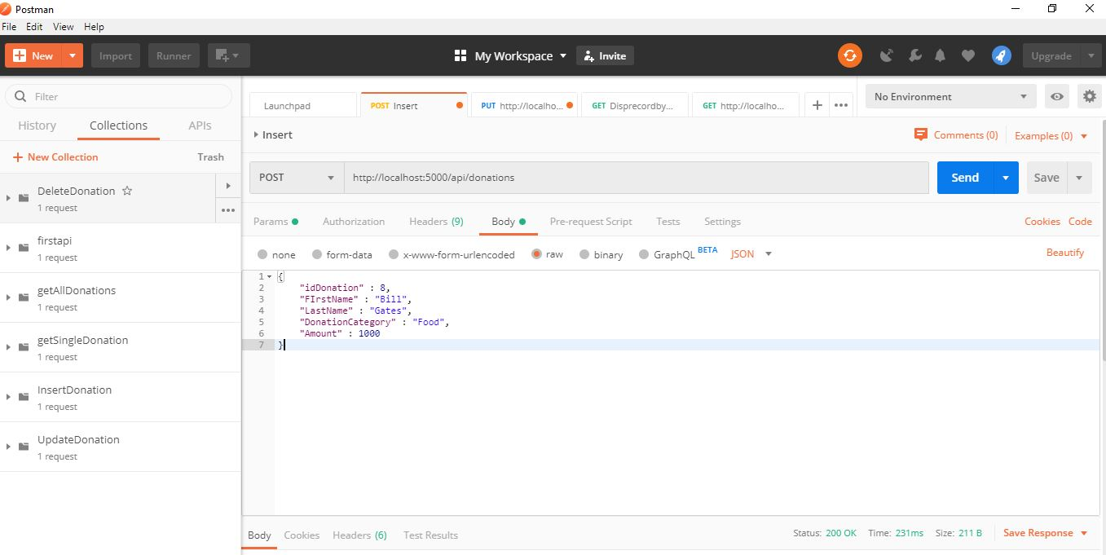
Post Method Implementation
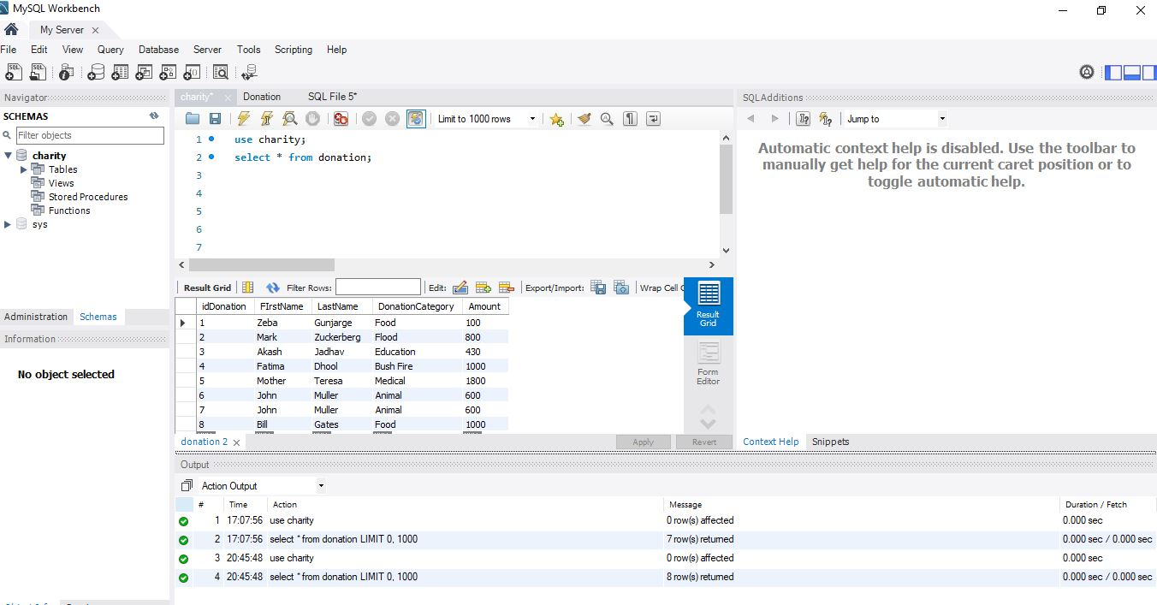
After Post-Database
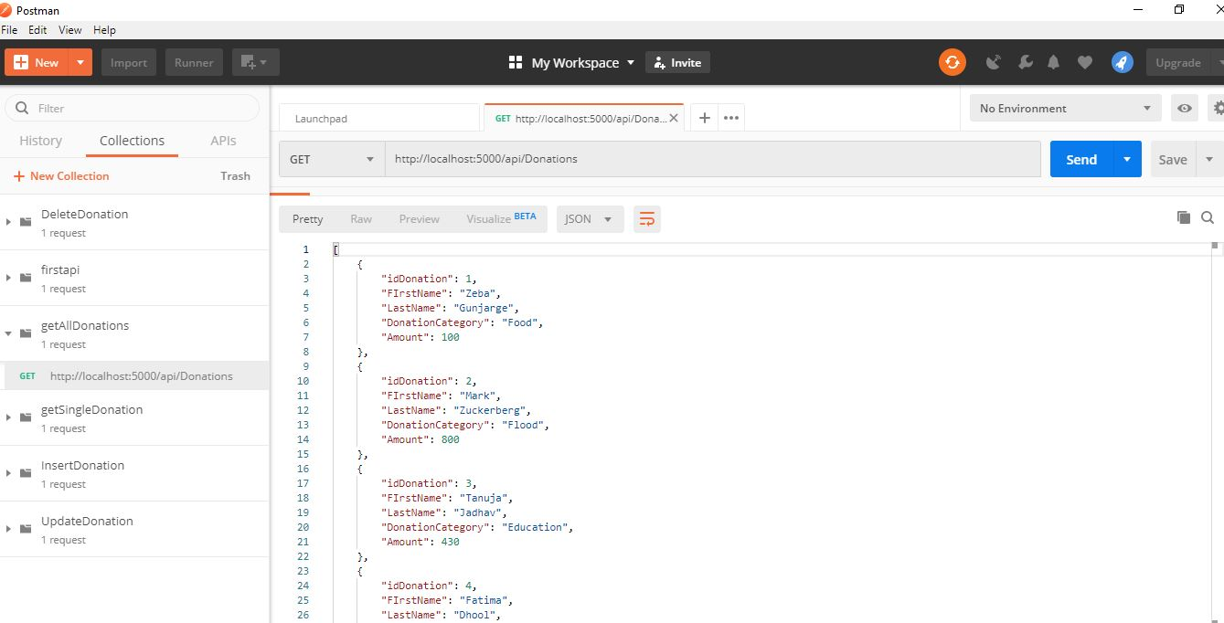
Postman-Getall()
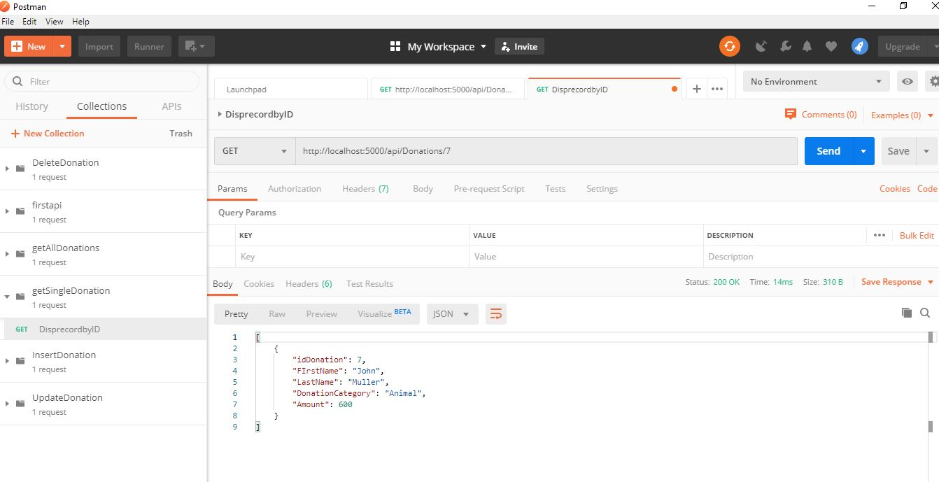
Postman Get Donation by ID
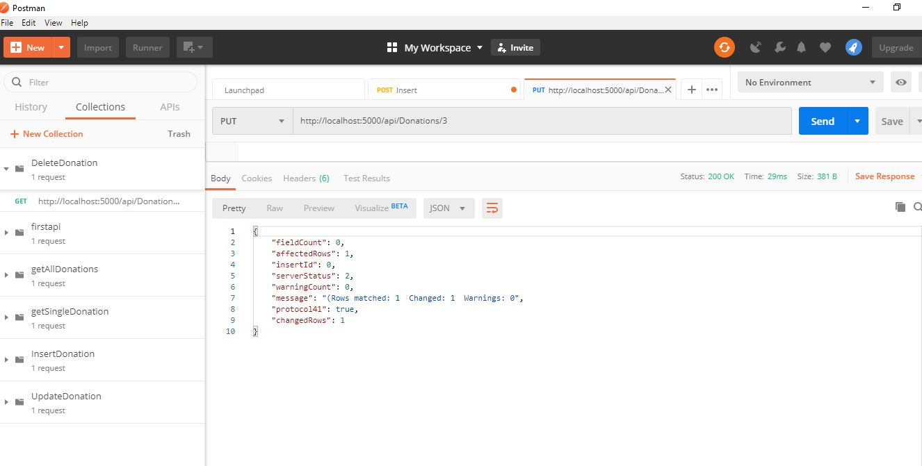
Postman Put ()
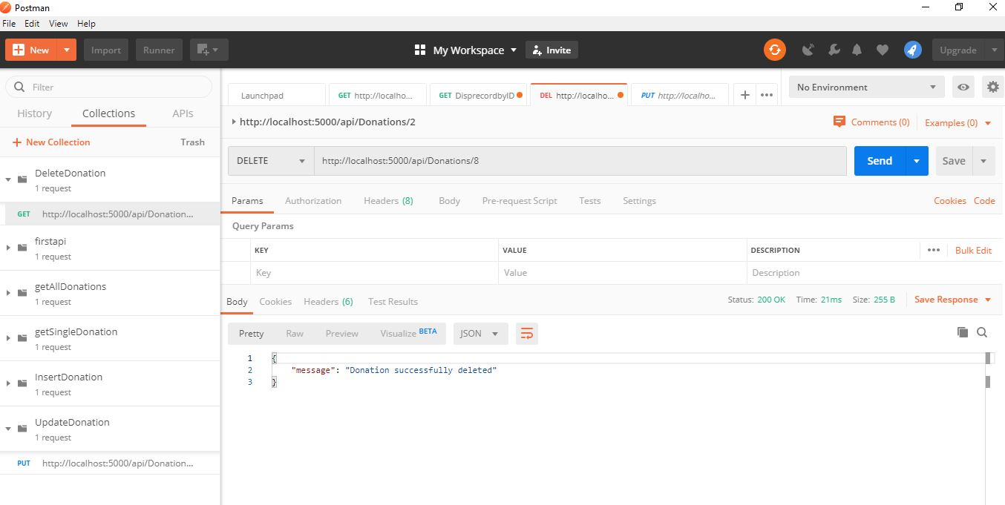
Postman Delete ()
Database after Delete

5. Future Enhancement
The following are the possible enhancement to the new system,

- The system could be modified suitably to work on a network. This involves, among other, resolving used conflicts, protecting database integrity and ensuring consistency of data if it is distributed across multiple locations.
- The system could be modified to add another provision of handling.
- We can add Different module to increase the efficiency of the system.
- Updating of the system is possible.
- New system can also be integrated.
- We can update real-time payment using PayPal gateway.

6. Conclusion

Although this section on Natural calamity, Animal, Education and Medical in the management and sustainable use of the environment has been only exploratory, it is hoped that it will serve as a basis to enhance the people’s issues. In conclusion, non-profit organization and charity project usually boasts the network of supporters that can activate for various purpose including fundraising campaigns.
But making transaction online means requires lots of extra work and needs lot of preparation. This requires knowledge of marketing, social networking and social marketing techniques in order converse with customer, as well as familiarity with customer and conversation as well. Charity is only where we give goods service or money without any gain, benefits or recognition of any kind. True charity is anonymous. It begins and ends with yourself.

